**Project 4 – MLB Ticker**

Sketch uses an 8x32 LED array with the 7219 module to display MLB scores from 08/09/2018

has a function, writeLine(int, String), which writes a line of text one character at a time using the LcdDataWrite() function on line 0, 1, 2, or 3 of the display. This function expects either 0, 1, 2 or 3 for the first argument, the line number to write, and a 20-character text string for the second argument. The function does not error check for string length.

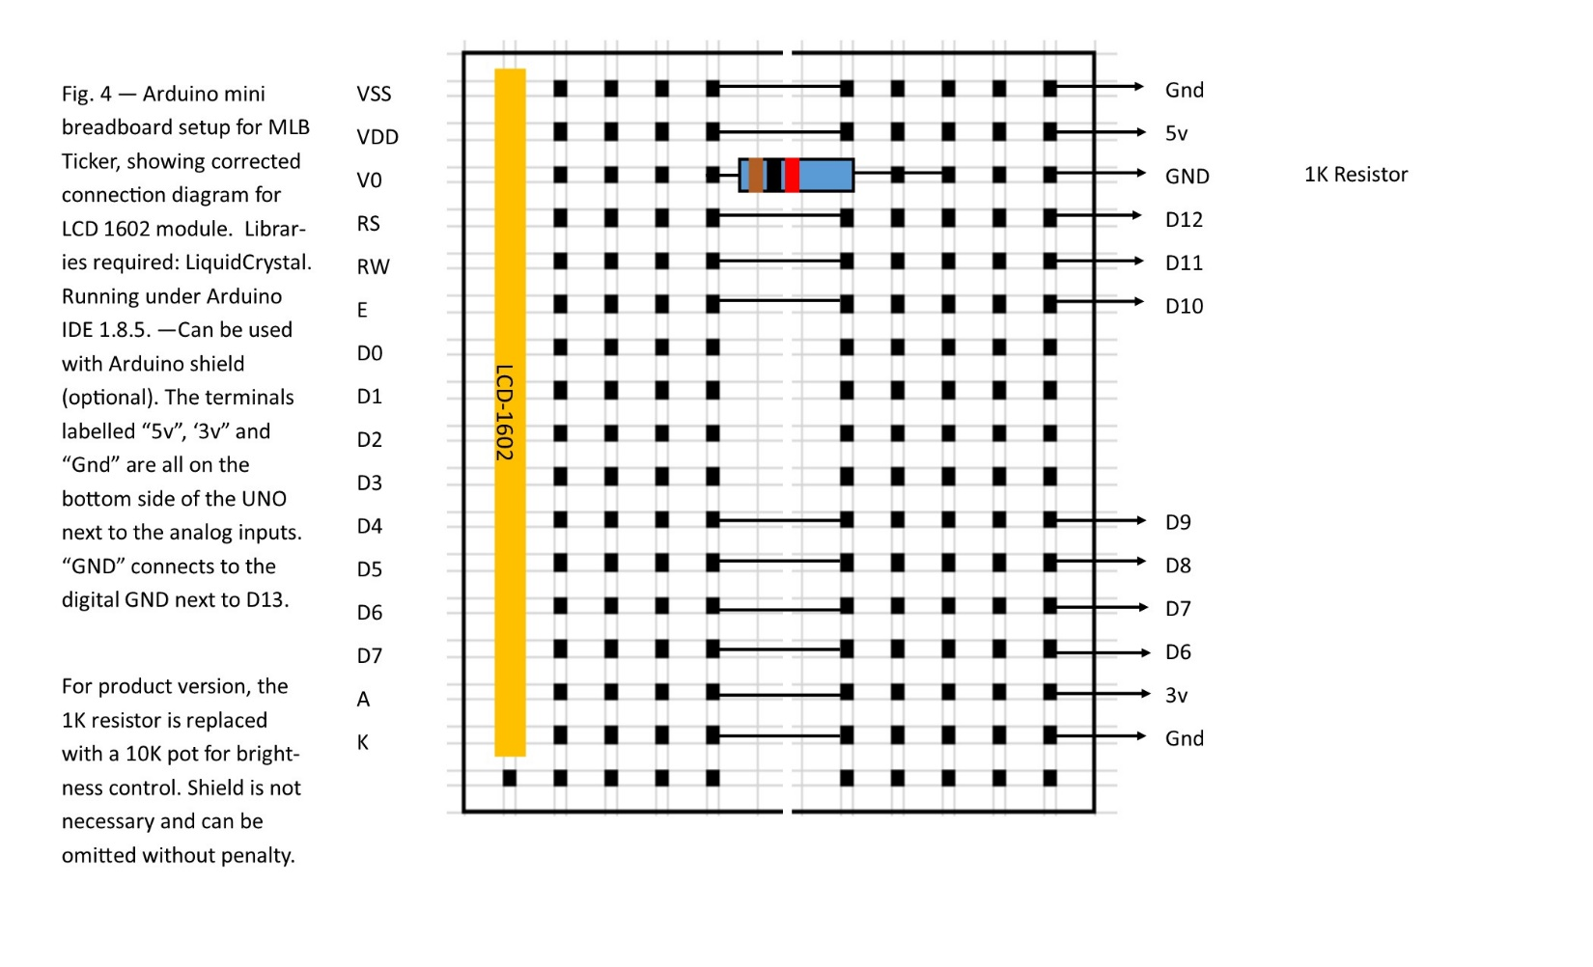

**Code for MLB Ticker**

#include <LiquidCrystal.h>

// This displays MLB Baseball scores for 08/09/2018

// 1602 Arduino 4 bit mode

// 1 VSS Gnd

// 2 VDD 5v

// 3 V0 TO 1K RESISTOR, OTHER LEAD TO GND

// 4 RS D12

// 5 RW D11

// 6 E D10

// 7 D0 --

// 8 D1 --

// 9 D2 --

// 10 D3 --

// 11 D4 D9

// 12 D5 D8

// 13 D6 D7

// 14 D7 D6

// 15 A 3v

// 16 K Gnd

// Common browsing,copying, saving and printing of code

int LCD1602_RS=12;

int LCD1602_RW=11;

int LCD1602_EN=10;

int DB[] = { 6, 7, 8, 9};

int dur=3000;

LiquidCrystal lcd(LCD1602_RS, LCD1602_EN, 9, 8, 7, 6);

void LCD_Command_Write(int command)

{

int i,temp;

digitalWrite( LCD1602_RS,LOW);

digitalWrite( LCD1602_RW,LOW);

digitalWrite( LCD1602_EN,LOW);

temp=command & 0xf0;

for (i=DB[0]; i <= 9; i++)

{

digitalWrite(i,temp & 0x80);

temp <<= 1;

}

digitalWrite( LCD1602_EN,HIGH);

delayMicroseconds(1);

digitalWrite( LCD1602_EN,LOW);

temp=(command & 0x0f)<<4;

for (i=DB[0]; i <= 10; i++)

{

digitalWrite(i,temp & 0x80);

temp <<= 1;

}

digitalWrite( LCD1602_EN,HIGH);

delayMicroseconds(1);

digitalWrite( LCD1602_EN,LOW);

}

void LCD_Data_Write(int dat)

{

int i=0,temp;

digitalWrite( LCD1602_RS,HIGH);

digitalWrite( LCD1602_RW,LOW);

digitalWrite( LCD1602_EN,LOW);

temp=dat & 0xf0;

for (i=DB[0]; i <= 9; i++)

{

digitalWrite(i,temp & 0x80);

temp <<= 1;

}

digitalWrite( LCD1602_EN,HIGH);

delayMicroseconds(1);

digitalWrite( LCD1602_EN,LOW);

temp=(dat & 0x0f)<<4;

for (i=DB[0]; i <= 10; i++)

{

digitalWrite(i,temp & 0x80);

temp <<= 1;

}

digitalWrite( LCD1602_EN,HIGH);

delayMicroseconds(1);

digitalWrite( LCD1602_EN,LOW);

}

void LCD_SET_XY( int x, int y )

{

int address;

if (y ==0) address = 0x80 + x; // line 0 starts at address 0x80

else address = 0xC0 + x; // line 1 starts at address 0xC0

LCD_Command_Write(address);

}

void LCD_Write_Char( int x,int y,int dat)

{

LCD_SET_XY( x, y ); // go to position x, line y

LCD_Data_Write(dat); // write one character

}

void LCD_Write_String(int y,char *s)

{

LCD_SET_XY( 0, y ); // address setup (char 0, line y)

while (*s) // write character string

{

LCD_Data_Write(*s);

s ++;

}

}

void setup (void)

{

int i = 0;

for (i=6; i <= 12; i++)

{

pinMode(i,OUTPUT);

}

delay(100);

lcd.begin(16,2); // INITIALIZE DISPLAY

LCD_Command_Write(0x28); // 4 wires, 2 lines 5x7

delay(50);

LCD_Command_Write(0x06);

delay(50);

LCD_Command_Write(0x0c);

delay(50);

LCD_Command_Write(0x80);

delay(50);

LCD_Command_Write(0x01);

delay(50);

LCD_Write_String(0,"Display v. 1.0.3");// line 1

LCD_Write_String(1," by Bill Jenkins");// line 2

delay(dur);

}

void loop (void)

{

LCD_Command_Write(0x01); // clear screen

delay(50);

LCD_Write_String(0," MLB Scores ");// line 1

LCD_Write_String(1," 08/09/2018 ");// line 2

delay(dur);

LCD_Command_Write(0x01); // clear screen

delay(50);

LCD_Write_String(0,"Braves 3");// line 1

LCD_Write_String(1,"Nationals 6");// line 2

delay(dur);

LCD_Command_Write(0x01); // clear screen

delay(50);

LCD_Write_String(0,"Twins 4");// line 1

LCD_Write_String(1,"Indians 5");// line 2

delay(dur);

LCD_Command_Write(0x01); // clear screen

delay(50);

LCD_Write_String(0,"Padres 8");// line 1

LCD_Write_String(1,"Brewers 4");// line 2

delay(dur);

LCD_Command_Write(0x01); // clear screen

delay(50);

LCD_Write_String(0,"Rangers 3");// line 1

LCD_Write_String(1,"Yankees 7");// line 2

delay(dur);

LCD_Command_Write(0x01); // clear screen

delay(50);

LCD_Write_String(0,"Red Sox 5");// line 1

LCD_Write_String(1,"Blue Jays 8");// line 2

delay(dur);

LCD_Command_Write(0x01); // clear screen

delay(50);

LCD_Write_String(0,"Orioles 4");// line 1

LCD_Write_String(1,"Rays 5");// line 2

delay(dur);

LCD_Command_Write(0x01); // clear screen

delay(50);

LCD_Write_String(0,"Mariners 8");// line 1

LCD_Write_String(1,"Astros 6");// line 2

delay(dur);

LCD_Command_Write(0x01); // clear screen

delay(50);

LCD_Write_String(0,"Dodgers 8");// line 1

LCD_Write_String(1,"Rockies 5");// line 2

delay(dur);

LCD_Command_Write(0x01); // clear screen

delay(50);

LCD_Write_String(0,"Pirates 10");// line 1

LCD_Write_String(1,"Giants 5");// line 2

delay(dur);

}

**Construction of Product**

Since the display is a small 16-character, 2-line LCD panel, it is well suited to things such as a price display, or anything displaying information to people at distances of not more than about 18”. A 10k pot is included on the final version of this project, in place of the 1K resistor. Batteries should be replaced or recharged once pack reaches 7.1V.